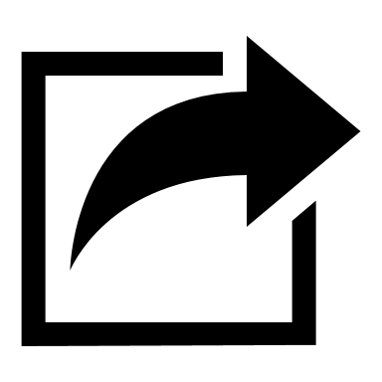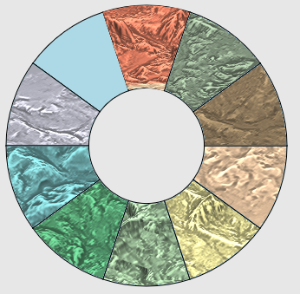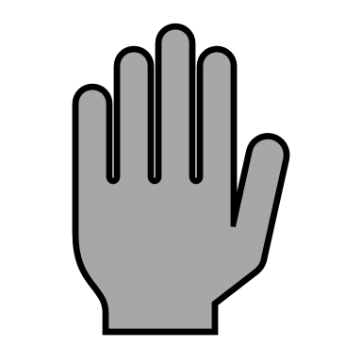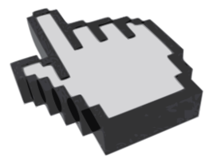

**3**

**2**

**Draw**

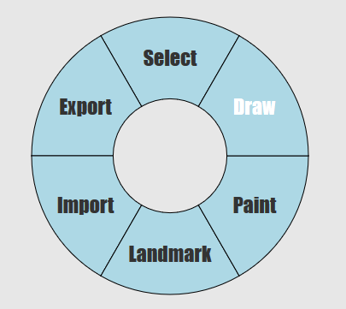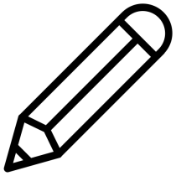

**1**

**1**

**3**

**2**

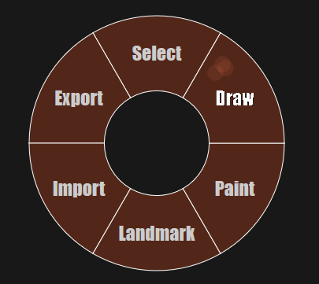

To Undo an action tap the B button on the right controller.

To teleport to a selected object/point tap the left hand trigger.

To delete a selected object/point tap the right hand trigger.

To de-select an object/point double tap the right index trigger.

To select an option move your hand in the corresponding direction. Once an option has been selected press the menu button again to exit the menu.

To select an object/point, point to it using the laser and tap the right index trigger.

Press the Menu Button on the left-hand controller to bring up the menu.

Welcome! These instructions will guide you through the program. Nod or perform the action described to dismiss the instruction

To change the paint brush width use the left hand joystick

To move around use the right-hand joystick.

To move the entire terrain with your hand hold down the left index trigger.

To paint an area, select a location using the laser and hold the right index trigger.

To create a point, select a location using the laser and tap the right index trigger. To draw a line, keep the trigger held down.

Select the back option to return to select mode.

Press the Menu Button on the left-hand controller to bring up the terrain-selection menu.